**КИЇВСЬКИЙ ФАХОВИЙ КОЛЕДЖ ЗВ’ЯЗКУ**

**WORK-CASE №4**

з дисципліни «Операційні системи»

Виконали: студенти **3** курсу, групи **КСМ-13А**

**Засенко Олександр**

(прізвище та ініціали)

**Дзюбенко Дмитро**

(прізвище та ініціали)

**Сторожук Костянтин**

(прізвище та ініціали)

Київ  2023

**ЗМІСТ**

Working with package managers …………….…………………………………...……..3

Package search………………………………………………………………..………….4

Package deleted…………………………..………………………………………………5

View a list of installed packages …………………………...……………………………6

Getting information and removing unnecessary or obsolete packages on CentOS………7

Updating the package manager and installing a new video or audio player……………..8

Installing Python………………………………………………………………………….9

Conclusions.……………………………………………………………………………..10

**Preparation**

**The material was prepared by a student Zasenko**

Working with package managers:

**Package**:

In the context of software, a package is an archived file that contains executables, libraries, configuration files, and other resources necessary for the installation and operation of a program or software component on an operating system. Packages usually contain all the necessary data to install and maintain the program, including instructions for the package manager to unpack and install the files.

Packages help standardize the process of installing programs and their dependencies on an operating system. They also provide the ability to easily update and uninstall programs, which simplifies system administration.

**Repository**:

A repository is a centralized repository or server that contains a set of software packages for a particular operating system or distribution. Repositories allow users to conveniently search for, install, update, and uninstall programs on their systems.

The main functions of repositories include:

1. **Package storage:** Repositories store a set of software packages that can be installed on a system.
2. **Version management:** Repositories typically allow users to select versions of programs to install and update.
3. **Dependencies and conflict tracking:** Repositories indicate dependencies between packages and avoid conflicts during installation.
4. **Package updates:** Repositories are updated regularly, allowing users to get updates and security measures for applications.
5. **Search and manage packages:** Users can use package management tools to find, install, update, and uninstall applications from repositories.

Repositories are used in various operating systems and distributions, such as Debian, Ubuntu, Red Hat, CentOS, and others, to facilitate the distribution and management of applications on these systems.

**Work progress**

***The material was prepared by a student Dziubenko***

1. The installed system in our previous work is CentOS, in the following information and screenshots will be from it. The CentOS system uses the yum package manager - Yellowdog Updater, Modified - an open console manager of RPM packages. It allows for cascading updates of Linux systems with tracking of RPM package relationships.

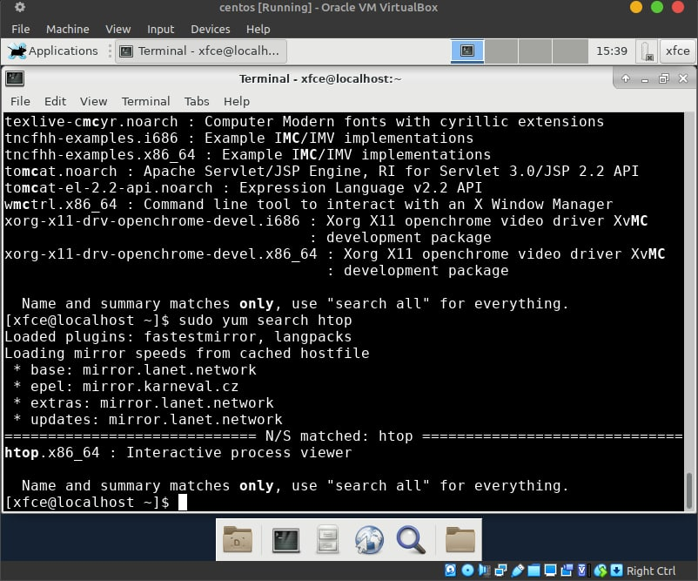

Fig 1. Starting the OS

Use the “search” command to search for packages by keywords:

**sudo yum search package_name**

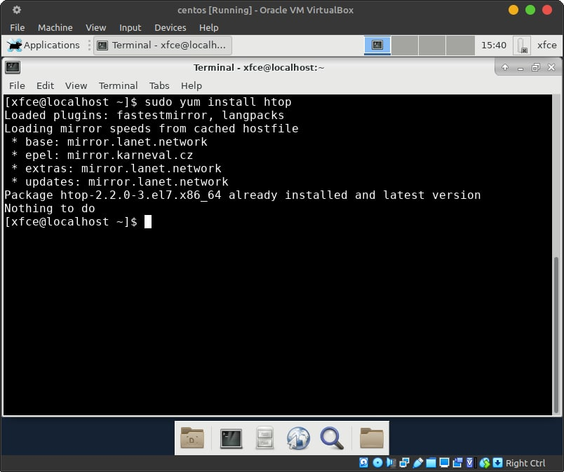

Fig 2. “Search” command

When you find the package you need, install it with the install command:

**sudo yum install package_name**

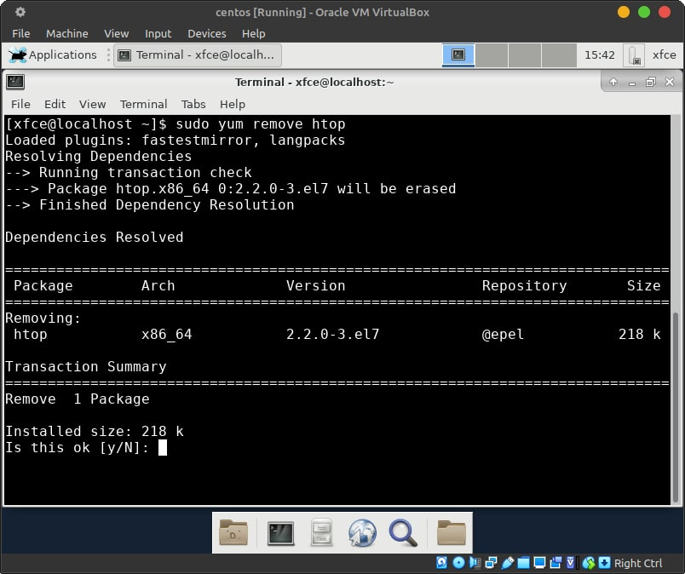

Fig 3. “Install” command

If you want to remove a package, use the remove command:

**sudo yum remove package_name**

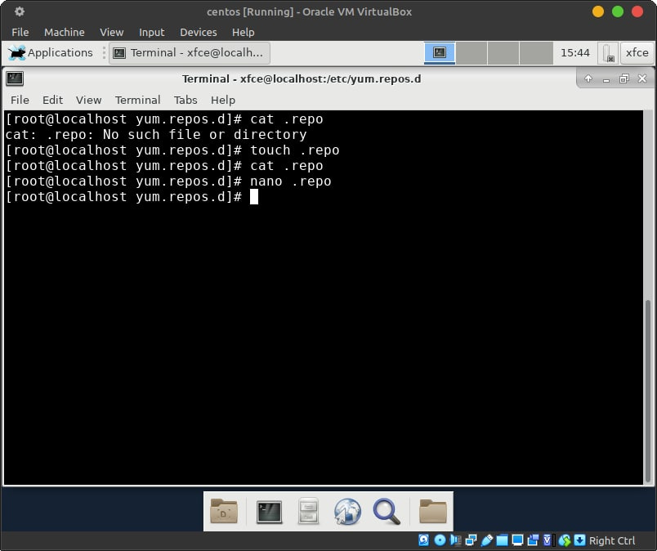

Fig 4. “Remove” command

Sometimes packages may be available in repositories that are not installed by default. To add a new repository, create a .repo file in the /etc/yum.repos.d/ directory with the necessary settings.

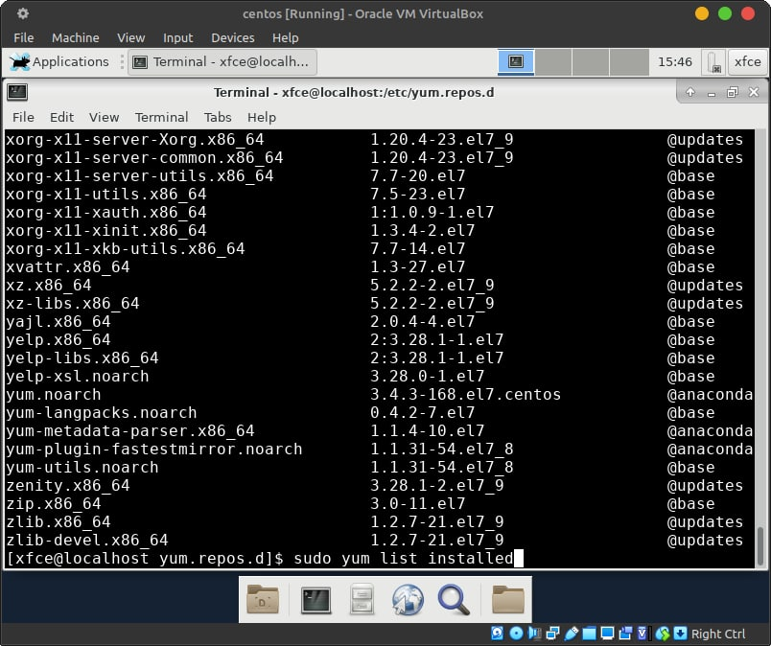

Fig 5. “List installed” command

To view a list of installed packages, use the yum list installed command:

**sudo yum list installed**

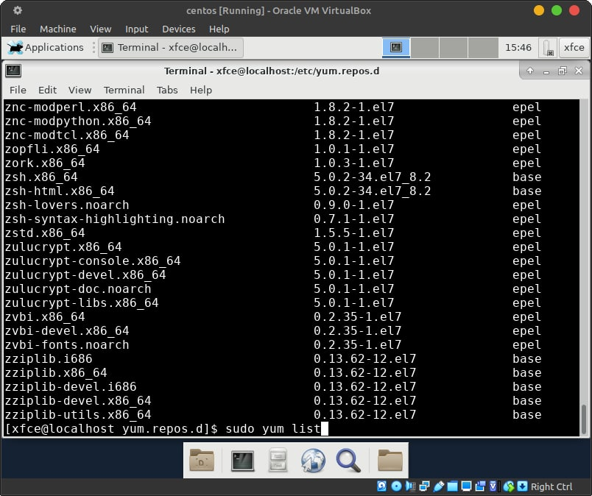

Fig 6. “List” command

To view a list of all available packages from repositories, use the yum list command without any parameters:

**sudo yum list**

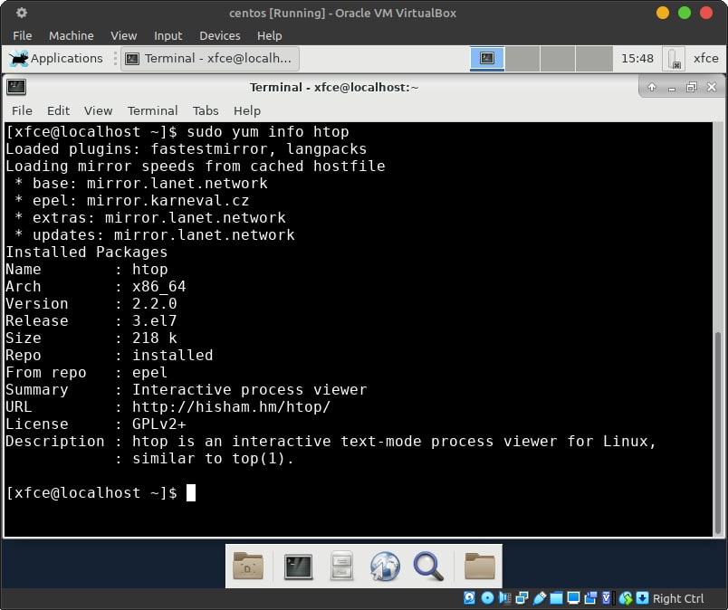

Fig 7. “Info” command

To get detailed information about a particular package, use the yum info command and specify the package name:

**sudo yum info package_name**

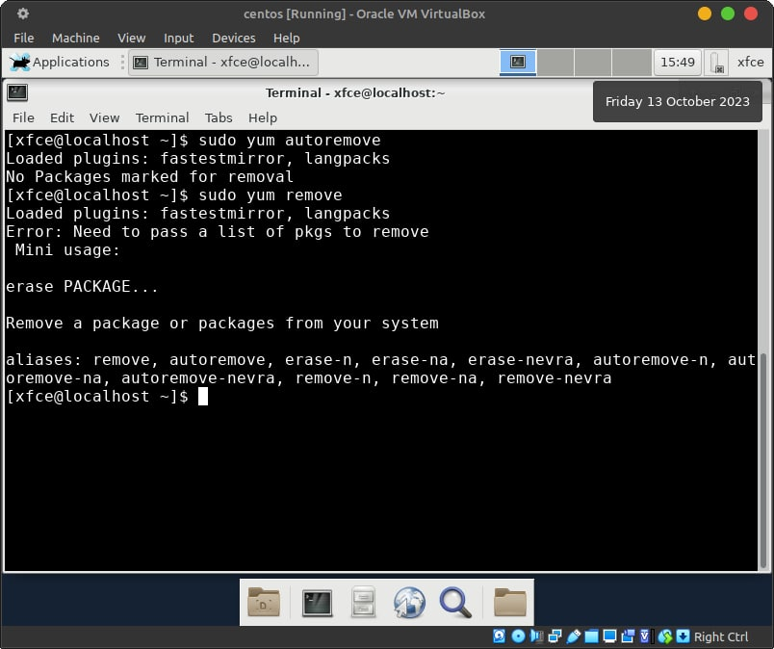

Fig 8. “Remove” command

To remove unnecessary or obsolete packages on CentOS, you can use the yum autoremove command to automatically remove unnecessary package dependencies, and the yum remove command to remove specific packages.

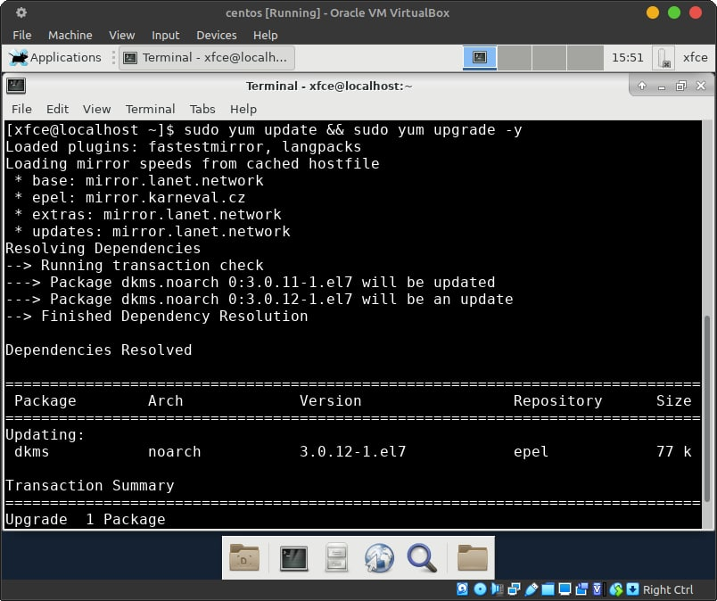

Fig 9. Update packages command

1. This will update the package manager and ensure that it works correctly on your system. On CentOS 8 and later, it is recommended that you use dnf as your primary package manager, as yum has been deprecated and is no longer supported in newer versions.

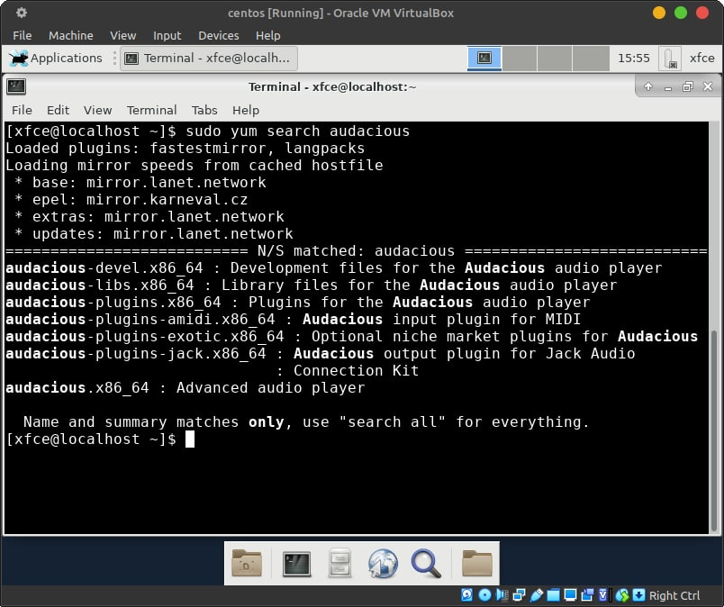

Fig 10. Package name command

If you want to install a new video or audio player or programming language environment via the package manager on your CentOS system, you first need to know the name of the packages you want to install.

To install audacious, run the following command with yum:

**sudo yum install audacious**

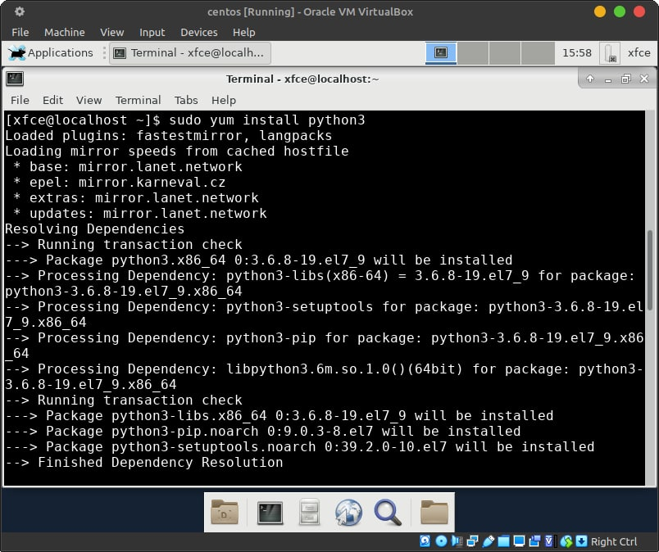

Fig 11. “Install python” command

To install Python, do the following:

**sudo yum install python3**

**sudo yum install python3-pip**

1. To install new apps through app stores and package managers in the GUI, you can use the GUI user interface, which provides the following features.

* **GNOME**: In the GNOME environment, you can use the "GNOME Software" (also known as "Software" or "Software Center") to install new programs. Open GNOME Software, find the application you want to install, and click the "Install" or "Get" button.
* **KDE**: In the KDE environment, you can use "Discover", which is the graphical package manager and app store for KDE Plasma. Open Discover, find the application and click "Install".

**Conclusions**

Through this work, we learned how to find, download, and install the necessary programs in Linux, namely a video player and an environment for the python programming language. The following worked on the work: Dziubenko - working with virtualbox, Zasenko - searching for information in Ukrainian, Storozhuk - translating the text and editing the file.